Input 1:
<FlightQuery>
<FlightNumber>CA937</FlightNumber>
<FlightDate>20030525</FlightDate>
</FlightQuery>

Output:
<FlightDetailsInfoResponse>
<Flight number="CA937" Flightdate="20030525">
<FirstClass>
<Capacity>48</Capacity>
<Used>2</Used>
<Price>300</Price>
</FirstClass>
<EconomyClass>
<Capacity>198</Capacity>
<Used>2</Used>
<Price>200</Price>
</EconomyClass>
<Origin>BEIJING</Origin>
<Destination>LONDON</Destination>
</Flight>
<ListOfPassengers>
<Passenger>
<ReservationNumber>CA937200305251</ReservationNumber>
<FirstName>Mary</FirstName>
<LastName>Smith</LastName>
<Class>F</Class>
</Passenger>
<Passenger>
<ReservationNumber>CA937200305252</ReservationNumber>
<FirstName>Diane</FirstName>
<LastName>Rose</LastName>
<Class>Y</Class>
</Passenger>
<Passenger>
<ReservationNumber>CA937200305253</ReservationNumber>
<FirstName>Debra</FirstName>
<LastName>Wiess</LastName>
<Class>Y</Class>
</Passenger>
<Passenger>
<ReservationNumber>CA937200305254</ReservationNumber>
<FirstName>Atila</FirstName>
<LastName>Wiess</LastName>
<Class>F</Class>
</Passenger>
</ListOfPassengers>
</FlightDetailsInfoResponse>

Required Queues:

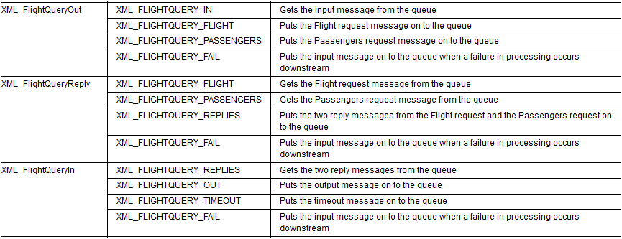

About the XML_FlightQueryOut message flow
XML_FlightQueryOut is the fan-out message flow in the aggregation example, XML_FlightQuery. XML_FlightQuery is constructed from three short message flows that communicate by getting, aggregating, and putting messages on to WebSphere MQ local queues. The three message flows in XML_FlightQuery are:
- XML_FlightQueryOut, the fan-out message flow, which generates and fans out two related requests for flight information and passenger information.
- XML_FlightQueryReply, which finds the information needed to reply to the two requests, see About the XML_FlightQueryReply message flow.
- XML_FlightQueryIn, the fan-in message flow, which combines the replies into a single reply message, see About the XML_FlightQueryIn message flow.
The input message for XML_FlightQuery requests information about a specific flight and the details of the passengers who have reserved seats on the flight.
The following diagram shows the XML_FlightQueryOut message flow.
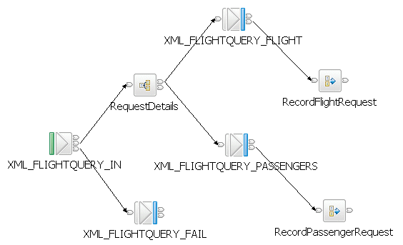
The following table lists the types of nodes that are used in the XML_FlightQueryOut message flow.
Node type | Node name
MQInput | XML_FLIGHTQUERY_IN
AggregateControl | RequestDetails
MQOutput | XML_FLIGHTQUERY_FAIL; XML_FLIGHTQUERY_FLIGHT; XML_FLIGHTQUERY_PASSENGERS
AggregateRequest | RecordFlightRequest; RecordPassengerRequest
For more information about the nodes that are used in this sample, see Built-in nodes in the WebSphere Message Broker documentation. To see the ESQL that is used in this message flow, see Creating the XML_FlightQueryOut message flow.
The XML_FlightQueryOut message flow performs the following actions:
- The XML_FLIGHTQUERY_IN node gets the request message from the XML_FLIGHTQUERY_IN queue and identifies the input message as being in the XMLNSC domain. The message flow must, therefore, parse the message by using the XMLNSC parser.
- The XML_FLIGHTQUERY_IN node passes the request message through the Out terminal to the RequestDetails node. Alternatively, if an exception has been produced downstream and the message is rolled back to here, the XML_FLIGHTQUERY_IN node passes the message through the Catch terminal to the XML_FLIGHTQUERY_FAIL node, which puts the message on the XML_FLIGHTQUERY_FAIL queue.
- The RequestDetails node generates the request messages:
  - A request for details of the flight listed in the input message: the flight request message
  - A request for a list of passengers with reservations on the flight listed in the input message: the passenger request message
- The RequestDetails node passes the flight request message through the Out terminal to the XML_FLIGHTQUERY_FLIGHT node, and passes the passenger request message through the Out terminal to the XML_FLIGHTQUERY_PASSENGERS node.
- The XML_FLIGHTQUERY_FLIGHT node puts the flight request message on the XML_FLIGHTQUERY_FLIGHT queue, and passes the flight request message through the Out terminal to the RecordFlightRequest node. Meanwhile, the XML_FLIGHTQUERY_PASSENGERS node puts the passenger request message on the XML_FLIGHTQUERY_PASSENGERS queue, and passes the passenger request message through the Out terminal to the RecordPassengerRequest node.
- The RequestDetails node stores the state of the aggregation internally in the broker.

About the XML_FlightQueryReply message flow
XML_FlightQueryReply is the reply message flow in the aggregation example, XML_FlightQuery. XML_FlightQuery is constructed from three short message flows which communicate by getting, aggregating, and putting messages on to WebSphere MQ local queues. The three message flows in XML_FlightQuery are:
- XML_FlightQueryOut, the fan-out message flow, which generates and fans out two related requests for flight information and passenger information, see About the XML_FlightQueryOut message flow.
- XML_FlightQueryReply, which finds the information needed to reply to the two requests.
- XML_FlightQueryIn, the fan-in message flow, which combines the replies into a single reply message, see About the XML_FlightQueryIn message flow.
The input message for XML_FlightQuery requests information about a specific flight, and the details of the passengers who have reserved seats on that flight.
The following diagram shows the XML_FlightQueryReply message flow.
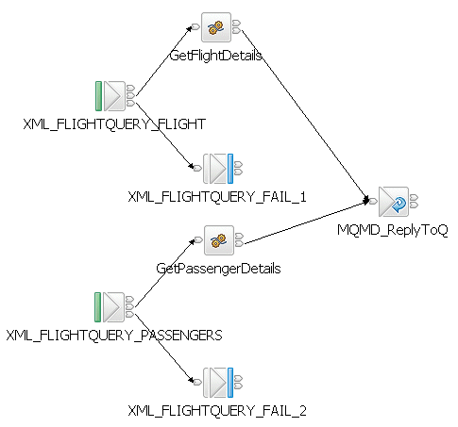
The following table lists the types of nodes that are used in the XML_FlightQueryReply message flow.
Node type | Node name
MQInput | XML_FLIGHTQUERY_FLIGHT; XML_FLIGHTQUERY_PASSENGERS
Compute | GetFlightDetails; GetPassengerDetails
MQReply | MQMD_ReplyToQ
MQOutput | XML_FLIGHTQUERY_FAIL_1; XML_FLIGHTQUERY_FAIL_2
For more information about the nodes that are used in this sample, see Built-in nodes in the WebSphere Message Broker documentation. To see the ESQL that is used in this message flow, see Creating the XML_FlightQueryReply message flow.
The XML_FlightQueryReply message flow performs the following actions:
- The XML_FLIGHTQUERY_FLIGHT node gets the request message from the XML_FLIGHTQUERY_FLIGHT queue, then passes the request message through the Out terminal to the GetFlightDetails node. Alternatively, if an exception has been produced downstream and the message has been rolled back to here, the XML_FLIGHTQUERY_FLIGHT node passes the message through the Catch terminal to the XML_FLIGHTQUERY_FAIL_1 node.
- The XML_FLIGHTQUERY_PASSENGERS node gets the request message from the XML_FLIGHTQUERY_PASSENGERS queue, then passes the request message through the Out terminal to the GetPassengerDetails node. Alternatively, if an exception has been produced downstream and the message has been rolled back, the XML_FLIGHTQUERY_PASSENGERS node passes the message through the Catch terminal to the XML_FLIGHTQUERY_FAIL_2 node, which puts the message on the XML_FLIGHT_QUERY_FAIL queue.
- The GetFlightDetails node accesses the XMLFLIGHTTB table in the RESERVDB database to obtain information about the flight specified in the request message, and appends to the request message information about capacity, seats allocated, and price for both Economy and First Class, and information about the origin and destination of the flight.
- The GetFlightDetails node passes the modified request message through the Out terminal to MQMD_ReplyToQ.
- The GetPassengerDetails node accesses the XMLPASSENGERTB table in the RESERVDB database to obtain information about the passengers that are booked on the flight that is specified in the request message, and appends to the request message a list of the passengers booked on the flight.
- The GetPassengerDetails node passes the modified request message through the Out terminal to MQMD_ReplyToQ.
- The MQMD_ReplyTo node checks the MQMD header of the message for the ReplyToQ and ReplyToQMgr values. The value of ReplyToQ is XML_FLIGHTQUERY_REPLIES, and the value of ReplyToQMgr is WBRK61_DEFAULT_QUEUE_MANAGER.
- The MQMD_ReplyTo node puts the message on the XML_FLIGHTQUERY_REPLIES queue. This queue name is not in the properties of the node; it is in the MQMD header of the message.
The XML_FlightQueryIn message flow continues the aggregation,

About the XML_FlightQueryIn message flow
XML_FlightQueryIn is the fan-in message flow in the aggregation example, XML_FlightQuery. XML_FlightQuery is constructed from three short message flows that communicate by putting and getting messages from WebSphere MQ queues. The three message flows in XML_FlightQuery are:
- XML_FlightQueryOut, the fan-out message flow, which generates and fans out two related requests for flight information and passenger information, see About the XML_FlightQueryOut message flow.
- XML_FlightQueryReply, which finds the information needed to reply to the two requests, see About the XML_FlightQueryReply message flow.
- XML_FlightQueryIn, the fan-in message flow, which combines the replies into a single reply message.
The input message for XML_FlightQuery requests information about a specific flight and the details of the passengers who have reserved seats on the flight.
The following diagram shows the XML_FlightQueryIn message flow.
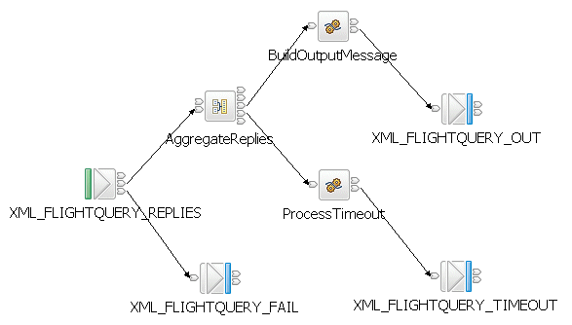
The following table lists the types of nodes that are used in the XML_FlightQueryIn message flow.
Node type | Node name
MQInput | XML_FLIGHTQUERY_REPLIES
AggregateReply | AggregateReplies
Compute | BuildOutputMessage; ProcessTimeout
MQOutput | XML_FLIGHTQUERY_OUT; XML_FLIGHTQUERY_TIMEOUT; XML_FLIGHTQUERY_FAIL
For more information about the nodes that are used in this sample, see Built-in nodes in the WebSphere Message Broker documentation. To see the ESQL that is used in this message flow, see Creating the XML_FlightQueryIn message flow.
The XML_FlightQueryIn message flow performs the following actions:
- The XML_FLIGHTQUERY_REPLIES node gets the two reply messages from the XML_FLIGHTQUERY_REPLIES queue, then passes each reply message through the Out terminal to the AggregateReplies node. Alternatively, if an exception has been produced downstream and the message has been rolled back to here, the XML_FLIGHTQUERY_REPLIES node passes the message through the Catch terminal to the XML_FLIGHTQUERY_FAIL node, which puts the message on the XML_FLIGHTQUERY_FAIL queue.
- The AggregateReplies node combines the two reply messages into a single, aggregated reply message, then passes the aggregated reply message through the Out terminal to the BuildOutputMessage node. If the aggregation times out because all of the replies have not arrived within the timeout interval (specified in the properties of the AggregateReplies node), the AggregateReplies node passes the incomplete aggregated message through the Timeout terminal to the ProcessTimeout node. The ProcessTimeout node then passes the message to the XML_FLIGHTQUERY_TIMEOUT node, which puts the message on the XML_FLIGHTQUERY_TIMEOUT queue.
- The BuildOutputMessage node builds a single output message from the information in the aggregated reply message. The output message contains the flight number and date; the capacity, number of seats booked, and seat price for each class; a list of passengers' names and their reservation numbers.
- The BuildOutputMessage node passes the output message through the Out terminal to the XML_FLIGHTQUERY_OUT node, which puts the output message on the XML_FLIGHTQUERY_OUT queue.

Creating the XML_FlightQueryOut message flow
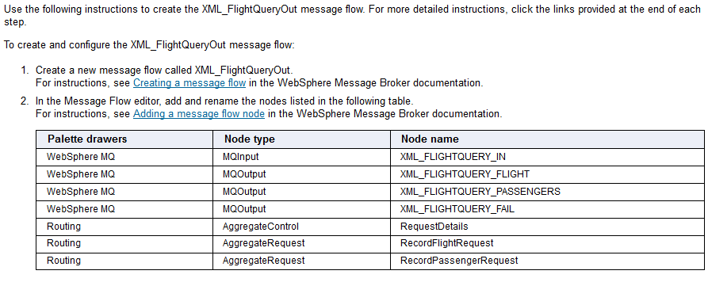

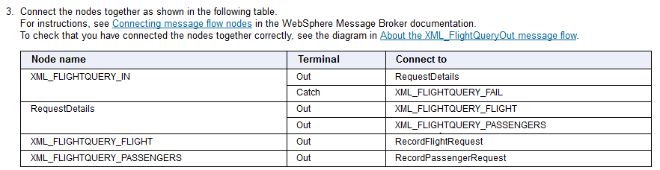
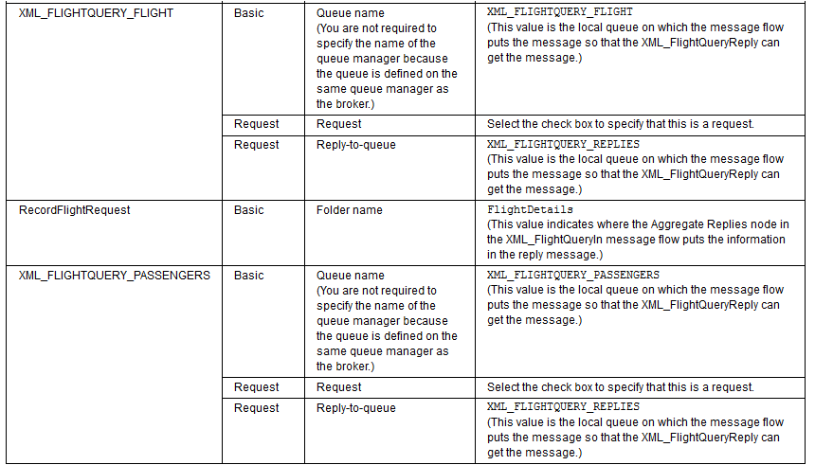
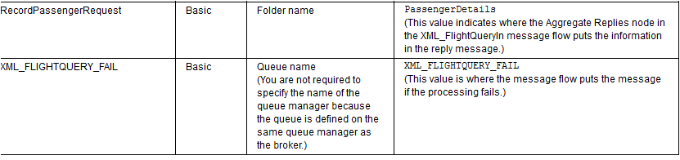

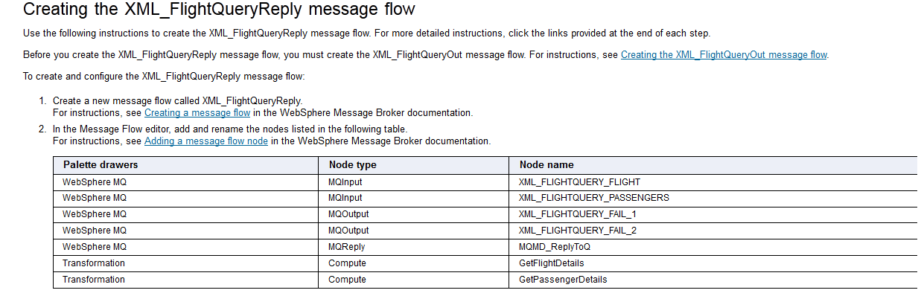

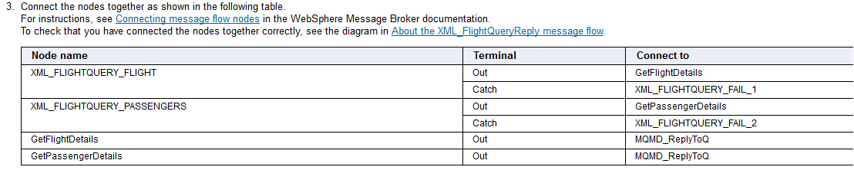

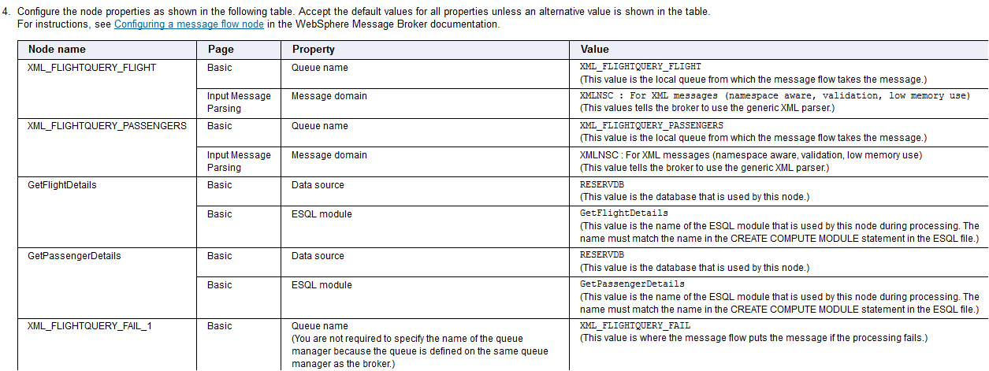

-- ************************************************
-- * ESQL for the XML_FlightQuery message flows
-- ************************************************

CREATE COMPUTE MODULE GetFlightDetails
CREATE FUNCTION Main() RETURNS BOOLEAN
BEGIN
SET OutputRoot = InputRoot;
SET OutputRoot.XMLNSC.FlightQuery = NULL;
CREATE FIELD OutputRoot.XMLNSC.Flight;
DECLARE outflight REFERENCE TO OutputRoot.XMLNSC.Flight;
DECLARE query REFERENCE TO InputRoot.XMLNSC.FlightQuery;
-- populate the output message with flight info from the database
SET OutputRoot.XMLNSC.Flight[] =
(SELECT T.* FROM Database.XMLFLIGHTTB AS T
WHERE T.FLIGHTNO = query.FlightNumber
AND T.FLIGHTDATE = query.FlightDate);
SET outflight.STARTPOINT = TRIM(outflight.STARTPOINT);
SET outflight.ENDPOINT = TRIM(outflight.ENDPOINT);
RETURN TRUE;
END;
END MODULE;

CREATE COMPUTE MODULE GetPassengerDetails
CREATE FUNCTION Main() RETURNS BOOLEAN
BEGIN
SET OutputRoot = InputRoot;
SET OutputRoot.XMLNSC.FlightQuery = NULL;
CREATE FIELD OutputRoot.XMLNSC.ListOfPassengers;
DECLARE outpass REFERENCE TO OutputRoot.XMLNSC.ListOfPassengers;
DECLARE query REFERENCE TO InputRoot.XMLNSC.FlightQuery;
-- populate the output message with passenger info from the database
SET outpass.PassengerDetails[] =
(SELECT T.* FROM Database.XMLPASSENGERTB AS T
WHERE T.FLIGHTNO = query.FlightNumber
AND T.FLIGHTDATE = query.FlightDate);
DECLARE I INTEGER 1;
DECLARE J INTEGER CARDINALITY(outpass.*[]);
WHILE I <= J DO
SET outpass.PassengerDetails[I].LASTNAME = TRIM(outpass.PassengerDetails[I].LASTNAME);
SET outpass.PassengerDetails[I].FIRSTNAME = TRIM(outpass.PassengerDetails[I].FIRSTNAME);
SET I = I + 1;
END WHILE;
RETURN TRUE;
END;
END MODULE;

Creating the XML_FlightQueryIn message flow
Use the following instructions to create the XML_FlightQueryIn message flow. For more detailed instructions, click the links provided at the end of each step.
Before you create the XML_FlightQueryReply message flow, you must create the XML_FlightQueryOut and XML_FlightQueryReply message flows. For instructions, see Creating the XML_FlightQueryOut message flow and Creating the XML_FlightQueryReply message flow.
To create and configure the XML_FlightQueryIn message flow:
- Create a new message flow called XML_FlightQueryIn.
For instructions, see Creating a message flow in the WebSphere Message Broker documentation.
- In the Message Flow editor, add and rename the nodes listed in the following table.
For instructions, see Adding a message flow node in the WebSphere Message Broker documentation.
Palette drawers | Type of node | Name of node
WebSphere MQ | MQInput | XML_FLIGHTQUERY_REPLIES
WebSphere MQ | MQOutput | XML_FLIGHTQUERY_OUT
WebSphere MQ | MQOutput | XML_FLIGHTQUERY_TIMEOUT
WebSphere MQ | MQOutput | XML_FLIGHTQUERY_FAIL
Transformation | Compute | BuildOutputMessage
Transformation | Compute | ProcessTimeout
Routing | AggregateReply | AggregateReplies
- Connect the nodes together as shown in the following table.
For instructions, see Connecting message flow nodes in the WebSphere Message Broker documentation.
To check that you have connected the nodes together correctly, see the diagram in About the XML_FlightQueryIn message flow.
Node name | Terminal | Connect to
XML_FLIGHTQUERY_REPLIES | Out | AggregateReplies (In terminal)
XML_FLIGHTQUERY_REPLIES | Catch | XML_FLIGHTQUERY_FAIL
AggregateReplies | Out | BuildOutputMessage
AggregateReplies | Timeout | ProcessTimeout
BuildOutputMessage | Out | XML_FLIGHTQUERY_OUT
ProcessTimeout | Out | XML_FLIGHTQUERY_TIMEOUT
- Configure the node properties as shown in the following table. Accept the default values for all properties unless an alternative value is shown in the table.
For instructions, see Configuring a message flow node in the WebSphere Message Broker documentation.
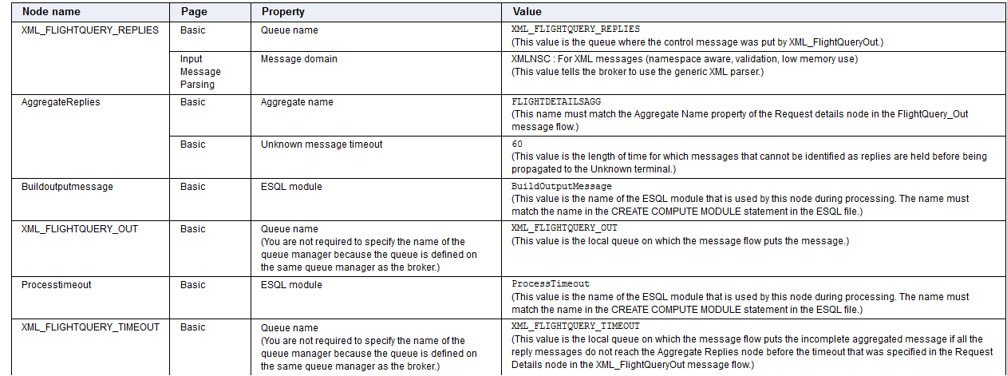
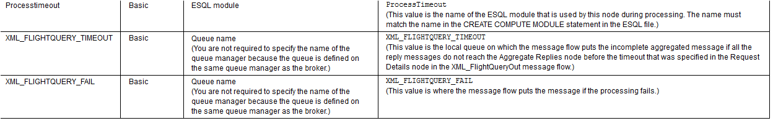

CREATE COMPUTE MODULE BuildOutputMessage
CREATE FUNCTION Main() RETURNS BOOLEAN
BEGIN
-- fix the aggregate reply message for output to a queue
SET OutputRoot.Properties = InputRoot.Properties;
CREATE NEXTSIBLING OF OutputRoot.Properties DOMAIN 'MQMD';
SET OutputRoot.MQMD.Version = MQMD_CURRENT_VERSION;

DECLARE inflight REFERENCE TO InputRoot.ComIbmAggregateReplyBody.FlightDetails.XMLNSC.Flight;
DECLARE inpass REFERENCE TO InputRoot.ComIbmAggregateReplyBody.PassengerDetails.XMLNSC.ListOfPassengers;
CREATE FIELD OutputRoot.XMLNSC.FlightDetailsInfoResponse;
DECLARE outresp REFERENCE TO OutputRoot.XMLNSC.FlightDetailsInfoResponse;

-- populate the output message with flight info from the aggregate reply
-- CREATE FIRSTCHILD OF outresp.Flight TYPE NameValue NAME 'number' VALUE inflight.FLIGHTNO;
SET outresp.Flight.(XMLNSC.Attribute)number VALUE = inflight.FLIGHTNO;
SET outresp.Flight.(XMLNSC.Attribute)Flightdate VALUE = inflight.FLIGHTDATE;
SET outresp.Flight.FirstClass.Capacity = inflight.TOTALFIRST;
SET outresp.Flight.FirstClass.Used = inflight.FIRSTCLASS;
SET outresp.Flight.FirstClass.Price = inflight.FIRSTPRICE;
SET outresp.Flight.EconomyClass.Capacity = inflight.TOTALECONOMIC;
SET outresp.Flight.EconomyClass.Used = inflight.ECONOMICCLASS;
SET outresp.Flight.EconomyClass.Price = inflight.ECONOMICPRICE;
SET outresp.Flight.Origin = inflight.STARTPOINT;
SET outresp.Flight.Destination = inflight.ENDPOINT;

-- populate the output message with passenger info from the aggregate reply
DECLARE I INTEGER 1;
DECLARE J INTEGER CARDINALITY(inpass.*[]);
WHILE I <= J DO
SET outresp.ListOfPassengers.Passenger[I].ReservationNumber = inpass.PassengerDetails[I].RESERVATIONNO;
SET outresp.ListOfPassengers.Passenger[I].FirstName = inpass.PassengerDetails[I].FIRSTNAME;
SET outresp.ListOfPassengers.Passenger[I].LastName = inpass.PassengerDetails[I].LASTNAME;
SET outresp.ListOfPassengers.Passenger[I].Class = inpass.PassengerDetails[I].CLASSTYPE;
SET I = I + 1;
END WHILE;
RETURN TRUE;
END;
END MODULE;
CREATE COMPUTE MODULE ProcessTimeout
CREATE FUNCTION Main() RETURNS BOOLEAN
BEGIN
SET OutputRoot.Properties = InputRoot.Properties;
CREATE NEXTSIBLING OF OutputRoot.Properties DOMAIN 'MQMD';
SET OutputRoot.MQMD.Version = MQMD_CURRENT_VERSION;
CREATE FIELD OutputRoot.XMLNSC.ComIbmAggregateReplyBody;
DECLARE timedout REFERENCE TO OutputRoot.XMLNSC.ComIbmAggregateReplyBody;
DECLARE reps REFERENCE TO InputRoot.ComIbmAggregateReplyBody;
MOVE reps FIRSTCHILD;
IF LASTMOVE(reps) THEN -- there will either be one reply, or none
SET timedout.TimedOut = reps.XMLNSC;
END IF;
RETURN TRUE;
END;
END MODULE;

Executed code:

CREATE COMPUTE MODULE GetFlightDetails
CREATE FUNCTION Main() RETURNS BOOLEAN
BEGIN
SET OutputRoot = InputRoot ;
SET OutputRoot.XMLNSC.FlightQuery = NULL;
CREATE FIELD OutputRoot.XMLNSC.Flight;
DECLARE outflight REFERENCE TO OutputRoot.XMLNSC.Flight;
DECLARE query REFERENCE TO InputRoot.XMLNSC.FlightQuery;

SET OutputRoot.XMLNSC.Flight[] = (SELECT T.* FROM Database.UPENDER.XMLFLIGHTTB AS T WHERE T.FLIGHTNO = query.FlightNumber AND T.FLIGHTDATE = query.FlightDate );
SET outflight.STARTPOINT = TRIM(outflight.STARTPOINT);
SET outflight.ENDPOINT = TRIM(outflight.ENDPOINT);

RETURN TRUE;
END;

CREATE PROCEDURE CopyMessageHeaders() BEGIN
DECLARE I INTEGER 1;
DECLARE J INTEGER;
SET J = CARDINALITY(InputRoot.*[]);
WHILE I < J DO
SET OutputRoot.*[I] = InputRoot.*[I];
SET I = I + 1;
END WHILE;
END;

CREATE PROCEDURE CopyEntireMessage() BEGIN
SET OutputRoot = InputRoot;
END;
END MODULE;

CREATE COMPUTE MODULE GetPassengerDetails
CREATE FUNCTION Main() RETURNS BOOLEAN
BEGIN
SET OutputRoot = InputRoot ;
SET OutputRoot.XMLNSC.FlightQuery = NULL ;
CREATE FIELD OutputRoot.XMLNSC.ListOfPassengers;
DECLARE outpass REFERENCE TO OutputRoot.XMLNSC.ListOfPassengers;
DECLARE query REFERENCE TO InputRoot.XMLNSC.FlightQuery;

SET outpass.PassengerDetails[] = (SELECT T.* FROM Database.UPENDER.XMLPASSENGERTB AS T WHERE T.FLIGHTNO= query.FlightNumber AND T.FLIGHTDATE = query.FlightDate );

DECLARE i INTEGER 1;
DECLARE j INTEGER CARDINALITY(outpass.*[]);

WHILE i <= j DO

SET outpass.PassengerDetails[i].LASTNAME=TRIM(outpass.PassengerDetails[i].LASTNAME);
SET outpass.PassengerDetails[i].FIRSTNAME=TRIM(outpass.PassengerDetails[i].FIRSTNAME);

SET i = i+1;

END WHILE;

RETURN TRUE;
END;

CREATE PROCEDURE CopyMessageHeaders() BEGIN
DECLARE I INTEGER 1;
DECLARE J INTEGER;
SET J = CARDINALITY(InputRoot.*[]);
WHILE I < J DO
SET OutputRoot.*[I] = InputRoot.*[I];
SET I = I + 1;
END WHILE;
END;

CREATE PROCEDURE CopyEntireMessage() BEGIN
SET OutputRoot = InputRoot;
END;
END MODULE;

CREATE COMPUTE MODULE ProcessTimeOut
CREATE FUNCTION Main() RETURNS BOOLEAN
BEGIN
SET OutputRoot.Properties=InputRoot.Properties;

CREATE NEXTSIBLING OF OutputRoot.Properties DOMAIN 'MQMD';

SET OutputRoot.MQMD.ReplyToQ = 'XML_FLIGHTQUERY_REPLIES';
SET OutputRoot.MQMD.Version=MQMDE_CURRENT_VERSION;

CREATE FIELD OutputRoot.XMLNSC.ComIbmAggregateReplyBody;
DECLARE timedout REFERENCE TO OutputRoot.XMLNSC.ComIbmAggregateReplyBody;
DECLARE reps REFERENCE TO InputRoot.ComIbmAggregateReplyBody;

MOVE reps FIRSTCHILD;

IF LASTMOVE(reps) THEN

SET timedout.TimedOut = reps.XMLNSC;
END IF;

RETURN TRUE;
END;

CREATE PROCEDURE CopyMessageHeaders() BEGIN
DECLARE I INTEGER 1;
DECLARE J INTEGER;
SET J = CARDINALITY(InputRoot.*[]);
WHILE I < J DO
SET OutputRoot.*[I] = InputRoot.*[I];
SET I = I + 1;
END WHILE;
END;

CREATE PROCEDURE CopyEntireMessage() BEGIN
SET OutputRoot = InputRoot;
END;
END MODULE;

CREATE COMPUTE MODULE BuildOutputMessage
CREATE FUNCTION Main() RETURNS BOOLEAN

BEGIN
SET OutputRoot.Properties=InputRoot.Properties;

CREATE NEXTSIBLING OF OutputRoot.Properties DOMAIN 'MQMD';

SET OutputRoot.MQMD.ReplyToQ = 'XML_FLIGHTQUERY_REPLIES';
SET OutputRoot.MQMD.Version=MQMDE_CURRENT_VERSION;

DECLARE inflight REFERENCE TO InputRoot.ComIbmAggregateReplyBody.FlightDetails.XMLNSC.Flight;
DECLARE inpass REFERENCE TO InputRoot.ComIbmAggregateReplyBody.PassengerDetails.XMLNSC.ListOfPassengers;

CREATE FIELD OutputRoot.XMLNSC.FlightDetailsResponseInfoResponse;
DECLARE outresp REFERENCE TO OutputRoot.XMLNSC.FlightDetailsResponseInfoResponse ;

CREATE FIRSTCHILD OF outresp.Flight TYPE NameValue NAME 'number' VALUE inflight.FLIGHTNO;

SET outresp.Flight.(XMLNSC.Attribute)number VALUE =inflight.FLIGHTNO;
SET outresp.Flight.(XMLNSC.Attribute)FlightDate VALUE =inflight.FLIGHTDATE;
SET outresp.Flight.FirstClass.Capacity = inflight.TOTALFIRST;
SET outresp.Flight.FirstClass.Used = inflight.FIRSTCLASS;
SET outresp.Flight.FirstClass.Price = inflight.FIRSTPRICE;

SET outresp.Flight.EconomyClass.Capacity = inflight.TOTALECONOMIC;
SET outresp.Flight.EconomyClass.Used =inflight.ECONOMICCLASS;
SET outresp.Flight.EconomyClass.Price=inflight.ECONOMICPRICE;
SET outresp.Flight.Orgin = inflight.STARTPOINT;
SET outresp.Flight.Destination = inflight.ENDPOINT;

DECLARE i INTEGER 1;
DECLARE j INTEGER CARDINALITY(inpass.*[]);

WHILE i <=j DO

SET outresp.ListOfPassengers.Passenger[i].ReservationNumber =inpass.PassengerDetails[i].RESERVATIONNO;
SET outresp.ListOfPassengers.Passenger[i].FirstName = inpass.PassengerDetails[i].FIRSTNAME;
SET outresp.ListOfPassengers.Passenger[i].LastName = inpass.PassengerDetails[i].LASTNAME;
SET outresp.ListOfPassengers.Passenger[i].Class=inpass.PassengerDetails[i].CLASSTYPE;

SET i =i + 1;

END WHILE;

RETURN TRUE;
END;

CREATE PROCEDURE CopyMessageHeaders() BEGIN
DECLARE I INTEGER 1;
DECLARE J INTEGER;
SET J = CARDINALITY(InputRoot.*[]);
WHILE I < J DO
SET OutputRoot.*[I] = InputRoot.*[I];
SET I = I + 1;
END WHILE;
END;

CREATE PROCEDURE CopyEntireMessage() BEGIN
SET OutputRoot = InputRoot;
END;
END MODULE;

